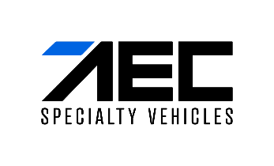

Press release

AEC adds GMC Yukon and Sierra to its growing General Motors vehicle lineup

Munich, Germany, September 18, 2024 – AEC Specialty Vehicles (AECSV), a subsidiary of AEC Group, specializing in customized automotive solutions, announces the addition of the 2025 GMC Yukon and Sierra to its growing import portfolio of General Motors vehicles, further expanding its broadest range of GM SUVs and trucks in Europe.
The MY25 GMC Yukon is the latest in AEC’s SUV lineup, offering a perfect blend of performance, capability, and luxury. Set to start production in October 2024, it joins the MY25 GMC Sierra, representing GMC's brand presence in Europe covering both full-size pick-up and SUV segments. This reflects AEC’s commitment to providing European customers with a comprehensive range of GM’s most innovative vehicles.
“We are thrilled to continue delivering imported Chevrolet, Cadillac, and GMC vehicles to car enthusiasts across Europe,” said Pere Brugal, President and Managing Director of General Motors Europe. “AEC’s deep knowledge of both the European market and our North American business ensures that these efficient ICE SUVs and trucks will continue to be enjoyed by European customers.”
Andrew Pilsworth, CEO of AEC, added, "The GMC brand has always been important to me. My career started over 25 years ago at a Pontiac, Buick, and GMC dealership in Canada. Bringing this exceptional lineup to European customers is a personal and professional highlight. GMC vehicles combine strength, innovation, and style, and I’m proud to deliver that experience to Europe.”

ABOUT AEC SPECIALTY VEHICLES
AEC Specialty Vehicles (AECSV) was founded in 2023 in St. Catharines, Canada, as a subsidiary of AEC Group, a group of several privately held companies specialized in the development of customized automotive solutions. With a focus on automotive import, distribution, homologation, and aftersales services, AECSV supports its partners from local dealerships to established OEMs as they enter new markets, further expand their business, and grow their brands. AECSV is an official European importer and distributor of General Motors (GM) Silverado, Sierra, Escalade, Tahoe, Suburban, and Yukon models. Learn more at www.aecsv.com.

For media inquiries or further information, please contact:

Georgia Chapman
PR & Corporate Communications
g.chapman@aecsolutions.com
+49 (0) 157 7499 2822

